Task List Application Test Plan
For quick testing, the Automated Test should work. For full testing, do all tests in this document.
Automated Test
Test | Description/Steps | Expected output | P/F
1 | Run the “debug” command.  - Type “debug” (no quotes) and press enter | Inspect all output to make sure program is working properly
2 | Run the “quit” command.  - Type “quit” (no quotes) and press enter | Program closes
Manual Test
Test | Description/Steps | Expected output | P/F
1 | Open the program  - Double click the TaskListApp.exe file | Program launches  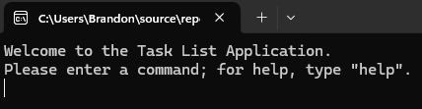
2 | Get help  - Type “help” (no quotes) and press enter (“Run” a command) | Help is displayed  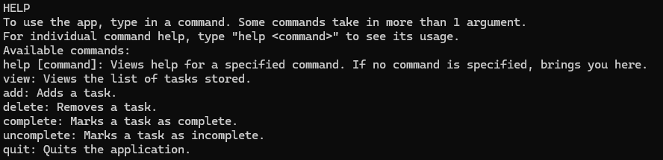
3 | Get help for view command  - Run “help view” | Help for “view” is displayed  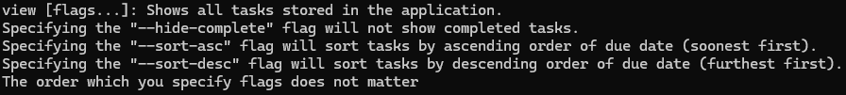
4 | Get help for add command  - Run “help add” | Help for “add” is displayed
5 | Get help for delete command  - Run “help delete” | Help for “delete” is displayed
6 | Get help for complete command  - Run “help complete” | Help for “complete” is displayed
7 | Get help for uncomplete command  - Run “help uncomplete” | Help for “uncomplete” is displayed
8 | Get help for quit command  - Run “help quit” | Help for “quit” is displayed
9 | Viewing empty list  - Run “view” | Message saying there are no tasks will display  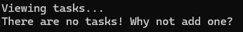
10 | Adding a task (DD/MM/YYYY, 1 word)  - Run “add 25/12/2025 Testing”  - Run “view” | After 1:  After 2:
11 | Adding a task (DD/MM, 1 word)  - Run “add 24/12 Testing2”  - Run “view” | After 1:  After 2:  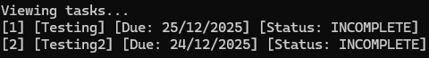  The year for [2] will be the current year
12 | Adding a task (DD/MM/YYYY, multi word)  - Run “add 1/1/2026 Testing long@ words123”  - Run “view” | After 1:  After 2:  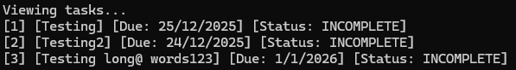
13 | Adding a task (DD/MM, multi word)  - Run “add 30/03 Multiple word sentence”  - Run “view” | After 1:  After 2:  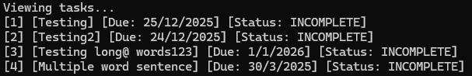
14 | Marking task 2 as complete  - Run “complete 2”  - Run “view” | After 1:  After 2:  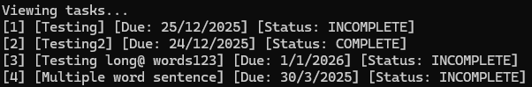
15 | Marking task 3 as complete  - Run “complete 3”  - Run “view” | After 1:  After 2:  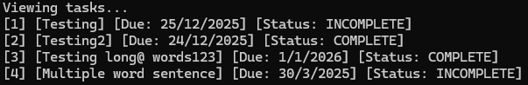
16 | Marking task 2 as incomplete  - Run “uncomplete 2”  - Run “view” | After 1:  After 2:  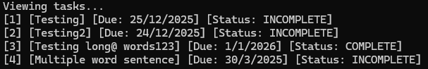
17 | Delete task 2  - Run “delete 2”  - Run “view” | After 1:  After 2:  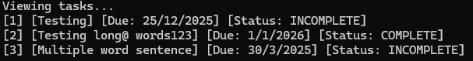  Verify that the former tasks 3 and 4 are now task 2 and 3
18 | View only incomplete tasks  - Run “view --hide-incomplete” | 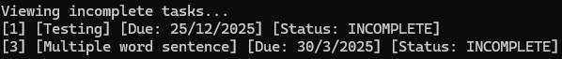  Task 2 is not shown as it is complete
19 | View tasks in ascending order  - Run “view --sort-asc” | 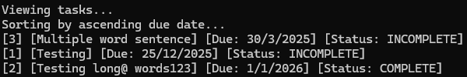  Tasks are shown soonest due date (or past) first
20 | View tasks in descending order  - Run “view --sort-desc” | 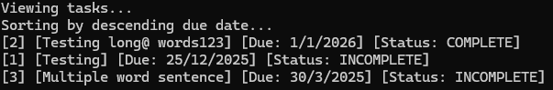  Tasks are shown furthest due date first
21 | Viewing only incomplete tasks in ascending order  - Run “view --hide-complete --sort-asc” | 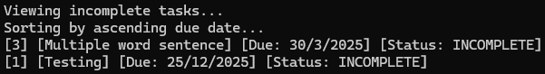
22 | Viewing only incomplete tasks in descending order  - Run “view --hide-complete --sort-desc” | 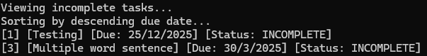
23 | Swapping order of flags in Test 21  - Run “view --sort-asc --hide-complete” | 
24 | Swapping order of flags in Test 22  - Run “view --sort-desc --hide-complete” | 
25 | Viewing with incorrect arguments  - Run “view testing random hehe” | 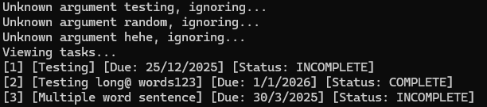  Invalid arguments will be ignored, viewing continues as normal
26 | Viewing with correct arguments between incorrect arguments  - Run “view testing --hide-complete random hehe”  - Run “view testing --hide-complete random --sort-desc hehe” | After 1:  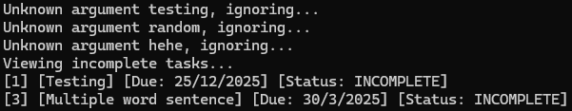  After 2:  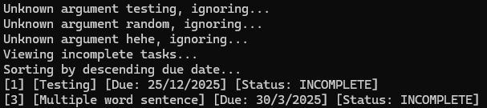
27 | Add a task with incorrect date format  - Run “add today do work”  - Run “view” | After 1:  After 2:  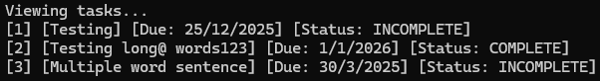  The task is not added (“today” is not DD/MM/YYYY or DD/MM)
28 | Add a task with invalid date  - Run “add 42/12/3024 do work”  - Run “view” | After 1:  After 2:    The task is not added (42 is not a valid day)
29 | Completing a non-number index  - Run “complete this”
30 | Completing an out-of-range index  - Run “complete 0”  - Run “complete 1000” | Both cases:
31 | Completing a task with extra rubbish arguments  - Run “complete 1 extra value”  - Run “view” | After 1:  Extra trailing arguments are ignored  After 2:  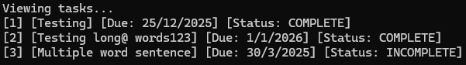
32 | Uncompleting a non-number index  - Run “uncomplete this”
33 | Uncompleting an out-of-range index  - Run “uncomplete 0”  - Run “uncomplete 1000” | Both cases:
34 | Uncompleting a task with extra rubbish arguments  - Run “uncomplete 1 extra value”  - Run “view” | After 1:  Extra trailing arguments are ignored  After 2:  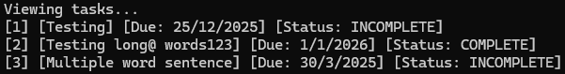
35 | Deleting a non-number index  - Run “delete this”
36 | Deleting an out-of-range index  - Run “delete 0”  - Run “delete 1000” | Both cases:
37 | Deleting a task with extra rubbish arguments  - Run “delete 1 extra value”  - Run “view” | After 1:  Extra trailing arguments are ignored  After 2:  Note that former tasks 2 and 3 are now tasks 1 and 2
38 | Quitting the application  - Run “quit” | Program closes

